Chapter Meeting Registration Form
FREE FREE FREE
for Pre-Registration ONLY

5001 Rockside Road, Independence, OH 44131
Cleveland Clinic Independence Family Health Center
Some words of CAUTION:
Due to the limitation on room capacity, Walk-Ins run the risk of being turned down at the door. We apologize for the inconvenience and hope you can Pre-Register.
Crown Centre II Bldg, Lower Level Conference Rm A & B
Located near I-77 and Rockside Rd Exit
FREE PARKING!!!

Meeting Date
December 15, 2011

Featured Speaker
David Soulsby, CCS-P

Topic
How to Bill Consults for Optimum Reimbursement

Agenda
4:30 – 5:00pm Registration (Must bring Member ID)
Chapter Business presented by Officers
5:00 – 7:00pm** Featured Speaker earn 2 CEUs
**Must arrive at 5pm and attend until 7pm in order to receive 2 CEUs

Pre-Registration: FREE by: December 12, 2011
Register at Door: $7.00
To register using paypal, visit www.clevelandaapc.com
Chapter ID#: 21606
Cut here*********************************************************************************************
Fill-in and Mail this Registration Form:
Pre- Registration: FREE
Register at Door: $7
Pre-Registration Due by:
December 12, 2011
Mail to: Bobbie Pope, 17158 Rabbit Run Drive, Strongsville, OH 44136

Meeting Date: December 15, 2011
Speaker: David Soulsby, CCS-P
Topic: How to Bill Consults for Optimum Reimbursement

Name: AAPC Member ID #:
Phone: Fax:
Address:
City/State/Zip:
Email:
Practice Name:
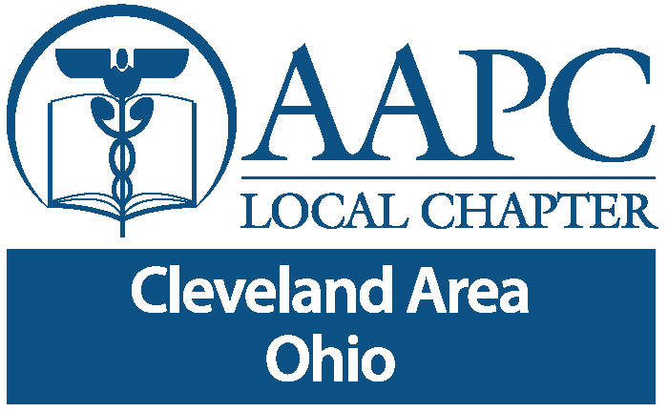Specialty:
Thank you for participating with yourAAPC Cleveland Area Local Chapter

